ABSTRACTION

The Minimal Farmers’ Market Price Tracker is more than just a digital tool—it’s a catalyst for grassroots empowerment. By enabling farmers to record and reference daily crop prices, it helps dismantle the information barriers that have long disadvantaged rural producers. This simple act of documentation can lead to more equitable transactions, better planning, and increased confidence in market interactions. Over time, communities can build informal price histories that serve as a collective memory, strengthening their ability to negotiate and advocate for fairer trade practices.
One of the most compelling aspects of the tracker is its offline-first architecture. In regions where internet access is unreliable or prohibitively expensive, the ability to use the app without connectivity is a game-changer. Users can input, store, and retrieve data locally, ensuring that the tool remains functional regardless of external conditions. This design choice reflects a deep understanding of the realities faced by rural users and prioritizes resilience over sophistication—a rare but essential perspective in tech development.
The tracker’s minimalist interface is intentionally designed to be intuitive and non-intimidating. With no need for logins, data syncing, or complex menus, users can begin recording prices immediately. This ease of use lowers the barrier to entry for individuals who may be unfamiliar with digital tools, including older farmers or those with limited literacy. The app’s simplicity also makes it easier to train others, fostering peer-to-peer learning and organic adoption within communities.
Beyond individual use, the tracker holds promise for collective action. Farmer cooperatives, local NGOs, and agricultural extension workers can use the tool to gather community-level data, identify pricing trends, and advocate for policy changes. By aggregating locally sourced information, these groups can build evidence-based cases for market reforms, infrastructure investments, or support programs. In this way, the tracker becomes not just a personal utility but a platform for systemic change.
Looking ahead, the Minimal Farmers’ Market Price Tracker could serve as a foundation for broader innovations. With modular enhancements, it could incorporate features like crop yield tracking, weather alerts, or community bulletin boards—all while preserving its core philosophy of minimalism. Its open-source potential invites collaboration from developers, researchers, and activists who share a vision of inclusive, user-centered technology. Ultimately, this project demonstrates that when tech listens closely to the needs of its users, even the simplest tools can spark profound transformation.

Acknowledgements
This project would not have been possible without the inspiration, support, and guidance of several individuals and communities who continue to shape the way we think about technology and its role in agriculture.

First and foremost, I extend my sincere gratitude to the local farming communities, whose daily challenges and resilience inspired the core idea behind this tracker. Their commitment to sustaining food systems despite limited resources is a testament to the strength of grassroots innovation.

I would also like to thank agricultural extension officers and market vendors, whose insights into pricing dynamics and rural commerce helped refine the practical aspects of this project. Their feedback ensured that the solution remained grounded in real-world needs.

Special appreciation goes to mentors, educators, and peers who provided valuable input during the conceptualization and development phases. Their encouragement and constructive criticism helped shape the project into a meaningful tool.

A heartfelt thanks to the open-source and tech communities, whose tools, documentation, and collaborative spirit made it possible to build a minimal yet impactful application. Their ethos of accessibility and shared knowledge aligns perfectly with the goals of this project.

Lastly, I acknowledge the broader mission of digital inclusion and sustainable development, which continues to inspire projects like this one. The Minimal Farmers’ Market Price Tracker is a small step toward a more equitable and informed agricultural ecosystem—and it stands on the shoulders of many who believe in that vision.

Introduction
In the age of digital transformation, agriculture has seen a surge of innovation—from drone-based crop monitoring to AI-driven yield prediction. Yet, many of these advancements remain out of reach for smallholder farmers who operate in low-resource environments. For them, even basic information like the daily market price of their produce can be difficult to obtain, leading to systemic disadvantages in trade and income generation.
The Minimal Farmers’ Market Price Tracker is conceived as a response to this overlooked need. It is not a high-tech marvel, but a humble, purposeful tool designed to bring clarity and fairness to local agricultural markets. The app allows users to manually record and view daily crop prices, either by entering data themselves or by accessing locally stored information. This approach ensures that the tool remains functional even in areas with poor or no internet access—a common reality in many farming communities.
What makes this project particularly compelling is its grounding in real-world utility. It doesn’t aim to revolutionize agriculture overnight but instead offers a stepping stone toward greater transparency and empowerment. By enabling farmers to track prices consistently, it helps them negotiate better deals, plan harvests more strategically, and build a stronger understanding of market dynamics.
Moreover, the project has educational and social value. It can be used by students studying agricultural economics, NGOs working with rural communities, or even local governments seeking to improve market efficiency. Its minimal design makes it adaptable to various contexts, and its focus on manual input encourages community participation and ownership.
In essence, the Minimal Farmers’ Market Price Tracker is a quiet but powerful tool—one that listens to the needs of the underserved and responds with clarity, simplicity, and purpose. It’s a reminder that sometimes, the most impactful innovations are not the most complex, but the most thoughtful.

Problem Statement
In many local markets, especially in rural and semi-urban areas, there is a lack of accessible and transparent information regarding daily grocery prices. This absence of real-time or historical price data makes it difficult for consumers to make informed purchasing decisions and for vendors to maintain fair pricing practices. Existing solutions are often complex, internet-dependent, or tailored to large-scale commercial systems, leaving a gap for simple, community-focused tools.
To address this issue, the Grocery Price App aims to provide a minimal, user-friendly website where users can manually input and view daily prices of essential grocery items. Built using Node.js and Express, the app focuses on simplicity, local data handling, and ease of use—making it ideal for small vendors, consumers, and community organizers seeking a lightweight solution for price tracking and comparison.

Who Is Affected and How
1. Small-scale farmers and vendors These individuals often sell their produce in local markets without access to consistent or transparent pricing data. Without a reliable way to track daily prices, they may unknowingly underprice their goods or be pressured by buyers who exploit the lack of information. This leads to reduced income, poor financial planning, and vulnerability to market fluctuations.
2. Consumers in rural and semi-urban areas Shoppers in these regions frequently face unpredictable pricing and may pay more than fair market value for basic groceries. Without visibility into price trends, they cannot compare costs or make informed purchasing decisions, which affects household budgeting and food security.
3. Community organizations and cooperatives Groups that support local agriculture or food distribution struggle to gather accurate data for planning, advocacy, or resource allocation. The absence of centralized or historical price records limits their ability to identify trends, negotiate better deals, or support policy changes.
4. Local governments and policymakers Officials aiming to stabilize food prices or support agricultural development lack grassroots-level data. Without tools to monitor real-time pricing, they may rely on outdated or incomplete information, leading to ineffective interventions or missed opportunities for targeted support.
5. Tech developers and innovators in underserved regions Developers trying to build solutions for rural markets face challenges when existing tools are too complex, internet-dependent, or misaligned with local needs. The lack of minimalist, offline-friendly platforms creates a gap in inclusive digital innovation.

Objectives
1. Promote Price Transparency in Local Markets The primary goal of the Minimal Market Price Tracker is to empower users—especially small-scale farmers and local vendors—with a simple tool to record and view daily grocery prices. By making price data visible and accessible, the project aims to reduce exploitation and promote fairer trade practices.
2. Enable Offline Functionality for Rural Accessibility Recognizing that many users operate in areas with limited or no internet connectivity, the project is designed to work offline. This ensures that users can input and retrieve price data without relying on external infrastructure, making the tool reliable and usable in remote settings.
3. Simplify User Experience Through Minimalist Design The website emphasizes ease of use with a clean, intuitive interface. It avoids unnecessary features, complex navigation, or login requirements, making it accessible to users with minimal digital literacy. The goal is to lower the barrier to entry and encourage widespread adoption.
4. Facilitate Manual Data Entry and Local Storage Instead of relying on automated data feeds or cloud databases, the app allows users to manually enter prices and store them locally. This approach gives users full control over their data and aligns with the realities of informal markets where digital infrastructure may be lacking.
5. Support Community-Level Decision Making By enabling individuals and groups to track price trends over time, the project supports better decision-making around selling, buying, and budgeting. It can also serve as a foundation for community-level initiatives, such as cooperative pricing strategies or local market analysis.
6. Lay the Groundwork for Future Enhancements While the current version focuses on core functionality, the project is designed to be extensible. Future updates could include features like multi-language support, crop yield tracking, or integration with SMS alerts—all while preserving the minimalist philosophy.

Objective Examples
To provide a digital alternative to handwritten price logs, improving accuracy and accessibility for rural vendors.
To reduce dependency on internet-based platforms by offering a fully functional offline experience.
To support community-level data collection for better market analysis and local decision-making.
To create a scalable foundation for future enhancements such as multi-user access, cloud syncing, or regional price comparisons.
To encourage digital literacy and technology adoption among small-scale farmers through a simple, intuitive interface.
To minimize technical barriers by using lightweight technologies like HTML, CSS, JavaScript, and Express.js..
To ensure cross-device compatibility so users can access the tracker on mobile phones, tablets, and desktops.
To promote fair pricing and reduce exploitation by enabling users to track and compare historical price trends.
To foster transparency and trust in local markets by decentralizing control over price data.
To demonstrate how minimalist design principles can solve real-world problems in underserved communities.

What the Project Includes
1. Manual Data Entry Users can input daily market prices for essential grocery items manually. This feature ensures flexibility and control, allowing farmers, vendors, and consumers to record prices based on their local observations without relying on automated feeds or external databases.

2. Local Storage The application uses browser-based local storage (such as localStorage or IndexedDB) to save price data directly on the user's device. This enables offline functionality, ensuring that users in low-connectivity areas can still access and manage their data without internet access.

3. Crop and Grocery Categories The tracker supports a predefined list of commonly traded crops and grocery items—such as rice, tomatoes, onions, and other regionally relevant produce. This categorization helps users organize their entries and quickly find the items they need to track.

4. Mobile-Friendly Interface The website is designed to be responsive and usable on smartphones, tablets, and desktops. This ensures accessibility for users who rely on mobile devices in rural or semi-urban settings.

5. Minimalist Design The user interface is clean and intuitive, with no login requirements, ads, or unnecessary features. This simplicity encourages adoption among users with limited digital literacy and keeps the focus on core functionality.

6. Daily Price Tracking Users can record and view prices on a day-by-day basis, helping them monitor trends, compare rates, and make informed decisions about buying or selling.

What the Project Does Not Include

1. Real-Time Price Feeds The application does not fetch live market prices from external sources or APIs. All data must be manually entered by users based on their local observations.
2. Cloud-Based Storage or Syncing The project does not include cloud storage, user accounts, or data synchronization across devices. All data is stored locally on the user's browser, which means it cannot be accessed from other devices or backed up online.
3. Multi-User or Role-Based Access The app does not provide charts, graphs, or statistical analysis of price trends. It focuses solely on basic data entry and retrieval.
4. Advanced Analytics or Reporting There is no support for multiple user roles (e.g., admin, contributor, viewer) or collaborative data entry. Each user operates independently with their own local data.
5. Notifications or Alerts There are no push notifications, SMS alerts, or reminders for price updates or market changes.
6. Language Localization The current version supports only one language (e.g., English) and does not include multi-language support or translation features.
7. Integration with External Systems The tracker does not connect with government databases, e-commerce platforms, or other agricultural tools. It is a standalone, minimal solution.
8. Security Features for Sensitive Data Since the app does not require login or store data online, it does not include encryption, authentication, or data protection mechanisms beyond browser defaults.

Existing Market Price Tracking Platforms
Several platforms aim to provide agricultural price data, including:
Agmarknet: A government-run portal that publishes daily prices from regulated markets across India.
Kisan Suvidha App: Offers market prices, weather updates, and expert advice for farmers.
AgriApp: Combines crop advisory with market price tracking and farming tips.
eNAM (National Agriculture Market): A pan-India electronic trading portal for agricultural commodities.

Frontend Overview
Technologies Used: HTML, CSS, JavaScript
Features:
Login screen (basic username/password check)
Language and area selection
Search bar for grocery items
Display of market and farmer prices
Design Philosophy:
Minimalist and mobile-friendly
No external libraries or frameworks
Offline-capable via local rendering and static files
Backend Overview
Technology Used: Node.js with Express
Endpoints:
GET /api/items: Returns the list of grocery items with prices
POST /api/update: Allows adding or updating items (for admin/developer use)
Data Storage:
Uses an in-memory JavaScript array (items[])
No database integration (keeps it lightweight)
Static File Serving:
Serves index.html and associated frontend files using express.static('.')
Data Flow and User Interaction
Login Phase:
User enters a username and password
If both fields are filled, frontend hides login and shows language/area selection
Selection Phase:
User selects preferred language and area
On clicking “Continue,” the dashboard is displayed
Dashboard Phase:
Frontend sends a GET request to /api/items
Server responds with a JSON array of grocery items
JavaScript filters and displays items based on search input
Search Interaction:
As the user types in the search bar, the frontend filters allItems[]
Matching items are displayed with market and farmer prices
Admin Update (Optional):
A developer or admin can send a POST request to /api/update with item details
Server updates or adds the item in the items[] array

Languages
HTML: Used to structure the content of the web pages, including forms, headings, and layout elements.
CSS: Provides styling for the user interface, ensuring a clean, readable, and mobile-friendly design.
JavaScript: Powers the interactive elements of the site, including login handling, search functionality, and dynamic data rendering.
Frameworks and Libraries
Express.js: A lightweight Node.js framework used to build the backend server and handle API routes.
(Optional) Bootstrap or React: These are not currently used in your code, but could be added in future versions to enhance styling (Bootstrap) or manage complex UI states (React).
Storage
LocalStorage: Used to store user-entered data directly in the browser, enabling offline access and persistent state across sessions.
IndexedDB (optional for future enhancement): A more advanced browser-based database that could be used for structured data storage and querying if the app scales.
Key Features
1. Crop Selection and Search Users can search for grocery items (e.g., Tomato, Potato, Apple) using a search bar. The app filters the list dynamically based on the input, allowing quick access to price data.
2. Price Display Each item displays two prices:
Market Price: The price at which the item is sold in local markets.
Farmer Price: The price received by the farmer, highlighting the gap between producer and consumer earnings.
3. Date Tracking (Implicit) While the current version does not store timestamps, the structure allows for future enhancement to include date-based entries. Users can manually update prices daily, simulating a time-based log.
4. Language and Area Selection Before accessing the dashboard, users select their preferred language (English, Hindi, Kannada) and area (Bengaluru, Mysuru, Hubli). This sets the context for localized price tracking.
5. Login Interface A basic login screen ensures that only authenticated users can proceed. It uses simple client-side validation without backend authentication.

Implementation of program
Frontend program:
In this we used HTML and CSS and JAVASCRIPT
Program
<!DOCTYPE html>
<html lang="en">
<head>
<meta charset="UTF-8" />
<title>Grocery Price Dashboard</title>
<style>
body { font-family: Arial; padding: 20px; }
.hidden { display: none; }
input, select, button { margin: 10px 0; padding: 8px; width: 100%; }
#results { margin-top: 20px; }
</style>
</head>
<body>
<div id="login">

<h1>MINIMAL FARMERS MARKET PRICE TRACKER</h1>
<h2>Login</h2>
<input type="text" id="username" placeholder="Username" />
<input type="password" id="password" placeholder="Password" />
<button onclick="handleLogin()">Login</button>
</div>

<div id="selection" class="hidden">
<h2>Select Language and Area</h2>
<select id="language">
<option value="English">English</option>
<option value="Hindi">Hindi</option>
<option value="Kannada">Kannada</option>
</select>
<select id="area">
<option value="Bengaluru">Bengaluru</option>
<option value="Mysuru">Mysuru</option>
<option value="Hubli">Hubli</option>
</select>
<button onclick="showDashboard()">Continue</button>
</div>

<div id="dashboard" class="hidden">
<h2>Grocery Price Dashboard</h2>
<input type="text" id="search" placeholder="Search for items..." oninput="searchItems()" />
<div id="results"></div>
</div>

<script>
let allItems = [];

function handleLogin() {
const user = document.getElementById('username').value;
const pass = document.getElementById('password').value;
if (user && pass) {
document.getElementById('login').classList.add('hidden');
document.getElementById('selection').classList.remove('hidden');
} else {
alert("Enter username and password");
}
}

function showDashboard() {
document.getElementById('selection').classList.add('hidden');
document.getElementById('dashboard').classList.remove('hidden');
fetch('/api/items')
.then(res => res.json())
.then(data => { allItems = data; searchItems(); });
}

function searchItems() {
const query = document.getElementById('search').value.toLowerCase();
const filtered = allItems.filter(item => item.name.toLowerCase().includes(query));
const html = filtered.map(item =>
`<div><strong>${item.name}</strong><br>Market: ₹${item.marketPrice} | Farmer: ₹${item.farmerPrice}</div>`
).join('');
document.getElementById('results').innerHTML = html || 'No results found';
}
</script>
</body>
</html>

Backend Program:
This contains the NODE .JS
Program:
const express = require('express');
const app = express();
const PORT = 3000;

app.use(express.json());
app.use(express.static('.')); // Serves index.html and other static files

let items = [
{ name: "Tomato", marketPrice: 30, farmerPrice: 25 },
{ name: "Potato", marketPrice: 20, farmerPrice: 18 },
{ name: "Apple", marketPrice: 100, farmerPrice: 90 },
{ name: "Wheat Seeds", marketPrice: 50, farmerPrice: 45 },
{ name: "Chickpeas", marketPrice: 60, farmerPrice: 55 }
];

// GET all items
app.get('/api/items', (req, res) => {
res.json(items);
});

// POST to update an item (for developer/admin)
app.post('/api/update', (req, res) => {
const { name, marketPrice, farmerPrice } = req.body;
const index = items.findIndex(i => i.name.toLowerCase() === name.toLowerCase());
if (index !== -1) {
items[index] = { name, marketPrice, farmerPrice };
res.json({ message: "Item updated" });
} else {
items.push({ name, marketPrice, farmerPrice });
res.json({ message: "Item added" });
}
});

app.listen(PORT, () => {
console.log(`Server running at http://localhost:${PORT}`);
});

To compile this backend with frontend code we have to use package.json
Code will be:
{
"name": "grocery-price-app",
"version": "1.0.0",
"description": "my first website",
"main": "server.js",
"scripts": {
"test": "echo \"Error: no test specified\" && exit 1",
"start": "node server.js"
},
"author": "",
"license": "ISC",
"dependencies": {
"express": "^5.1.0"
}
}

After compiling in terminal using the node.js version,it shows the output like this:
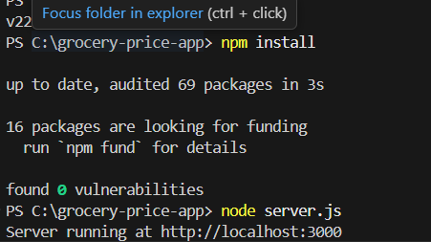
Then we have to copy the link as shown in the terminal:http://localhost:3000
And we have to paste this in google chrome or Microsoft to get final output,like this.
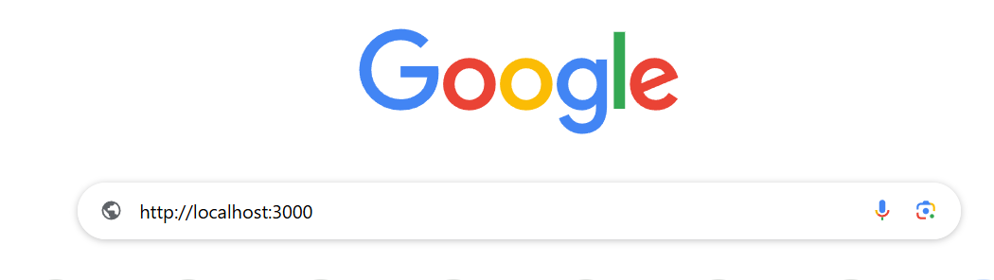
Then we have to give search then it shows the output like:
OUTPUT:
First page after searching:
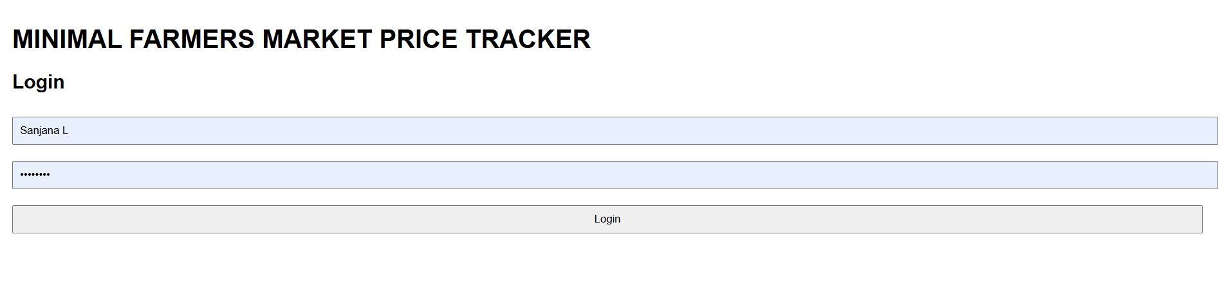

In this we have to put username and password after giving this we have to click on login button. Then we have to get other page to select he area and language like the below image.
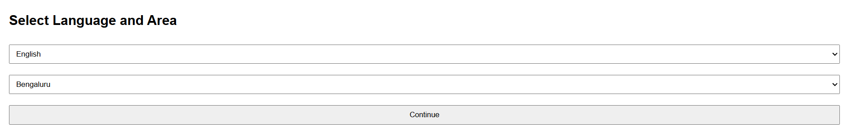

In this we have to select the language and area after selecting that we have click on the continue button. Then we will get the window page like the below image

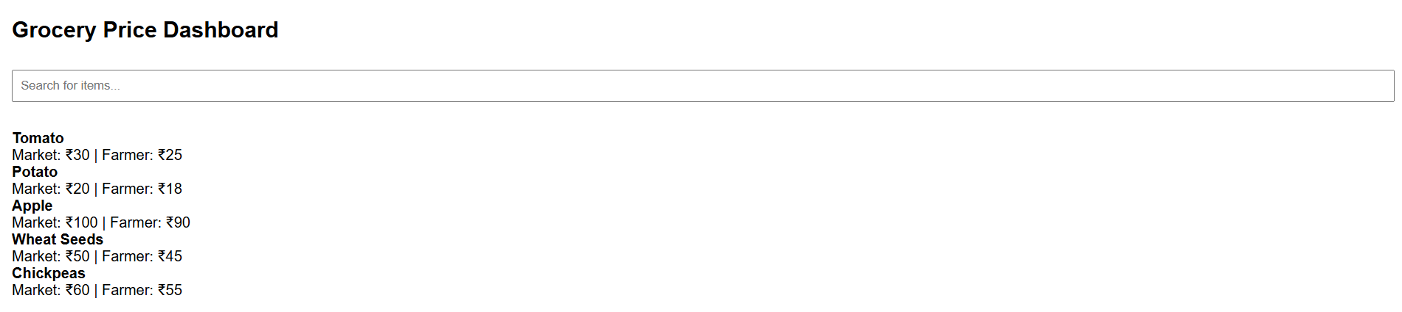

Not only this much we can give more items like this then in search bar we have to give the item name which we want to see the market price and the farmers price of a given item,like the below image.
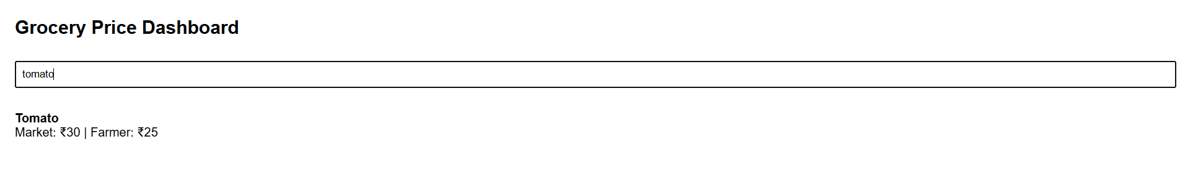

In the above image user search the amount of tomato near farmer and in market that shows both the price, this helps to farmers also to search price in market by that sellers cant cheat the farmer. This the reason of building this project to create a website on the minimal farmers price tracker.
User Interface Design
Design Philosophy: Minimalism and Accessibility
The user interface of the Minimal Farmers Market Price Tracker is intentionally designed with a minimalist approach to ensure clarity, ease of use, and accessibility for users with varying levels of digital literacy. The layout avoids clutter, focusing only on essential elements such as login fields, dropdowns, and a search bar. This simplicity reduces cognitive load and makes the application intuitive for first-time users, especially in rural or semi-urban settings.
Accessibility is enhanced through:
Clear labels and placeholder text
Large, clickable buttons
Full-width input fields for easier interaction on touch devices
No login complexity (no authentication backend)
Mobile Responsiveness
The interface is styled using basic CSS rules that ensure compatibility across devices. All input fields, buttons, and dropdowns use width: 100%, allowing them to adapt fluidly to smaller screens. Padding and spacing are used consistently to maintain readability and touch-friendly controls.
Although no external framework like Bootstrap is used, the layout remains responsive due to:
Simple vertical stacking of elements
Avoidance of fixed widths or pixel-based positioning
Use of scalable fonts and flexible containers
This ensures that the app works seamlessly on smartphones, tablets, and desktops without requiring additional styling libraries.
Color Scheme and Layout Choices
The color scheme is kept neutral and functional:
Font: Default system font (Arial) for readability
Background: Plain white for maximum contrast
Text and Buttons: Black text with standard button styling for clarity
Layout choices include:
Vertical flow from login → selection → dashboard
Use of <div> containers to separate logical sections
Hidden sections toggled via JavaScript (.hidden class) to simulate page transitions without reloading
These choices reinforce the app’s goal: to deliver a clean, distraction-free experience that prioritizes usability over aesthetics.

Manual Testing
The website was manually tested throughout the development process to ensure that all core features functioned as expected. Testing was performed on multiple devices and browsers to validate usability, responsiveness, and data handling. Key areas of focus included:
Login flow: Verified that users cannot proceed without entering both username and password.
Language and area selection: Confirmed dropdowns populate correctly and transition to the dashboard.
Dashboard rendering: Ensured that grocery items are fetched and displayed properly.
Search functionality: Tested dynamic filtering of items based on user input.
API responses: Validated that /api/items returns correct data and /api/update modifies or adds items as expected.

Technical and Design Hurdles
1. Lack of Backend Authentication
Challenge: The initial login system was purely client-side, meaning it didn’t validate credentials against a database or server. This raised concerns about security and user management.
Solution: To maintain simplicity while still guiding users through a structured flow, a basic input check was implemented. For future versions, a secure backend authentication system can be added using hashed passwords and session tokens.

2. Offline Functionality Without a Database
Challenge: Ensuring the app worked offline while still allowing users to view and interact with price data was difficult without a persistent database.
Solution: The app uses browser-based local storage and static files served via Express. This allows users to access the dashboard and search items without needing internet connectivity while keeping the architecture lightweight.

3. Dynamic Search Filtering
Challenge: Implementing real-time search filtering without external libraries required careful handling of user input and array manipulation.
Solution: A custom JavaScript function was written to filter the allItems array based on lowercase string matching. This approach is fast, simple, and works well for small datasets.

4. Mobile Responsiveness Without Frameworks
Challenge: Designing a responsive layout without using Bootstrap or other CSS frameworks required manual styling and testing across devices.
Solution: CSS rules were written using flexible units (width: 100%, padding, margin) and a vertical layout structure. Manual testing on mobile browsers confirmed that the interface remained usable and readable.

5. API Integration and Data Handling
Challenge: Creating a backend that could serve and update grocery item data without a database required careful handling of in-memory arrays.
Solution: The Express server was configured to use a simple JavaScript array for storing items. GET and POST routes were implemented to retrieve and update data, ensuring smooth communication between frontend and backend.

Conclusion:

The Minimal Farmers’ Market Price Tracker project provides a practical and innovative solution for managing and accessing agricultural price information. By offering daily updates on the prices of common crops like rice, tomato, and onion, it helps farmers, traders, and consumers make better economic decisions. Farmers can plan when and where to sell their produce for the best price, while consumers gain transparency about market fluctuations.

This project emphasizes the integration of technology in agriculture, encouraging the use of simple and affordable digital tools in rural areas. Its ability to store data locally or update it manually makes it suitable even for regions with limited internet access. The system’s simplicity ensures that users without advanced technical skills can still benefit from it easily.

Moreover, the tracker promotes fair trade practices, enhances market transparency, and reduces the communication gap between farmers and buyers. It also raises awareness about how technology can improve agricultural productivity and income stability.

In conclusion, the project is not just a software tool but a step toward empowering farmers and strengthening the agricultural economy. It demonstrates how minimal yet thoughtful innovation can bring meaningful change to the real world, especially in the farming community.

Future Scope:

The Minimal Farmers’ Market Price Tracker can be expanded in many ways to make it more efficient and useful for the agricultural community. In the future, the system can include automated data collection from government or market websites to update prices in real time. A mobile application version could also be developed to make the platform accessible to farmers on their smartphones, even in remote areas.

The tracker can be enhanced with data visualization features, such as graphs showing price trends over weeks or months, helping farmers make better predictions about crop demand and supply. Adding multi-language support would allow farmers from different regions to use the system comfortably in their local language.

Integration with weather forecasting and crop suggestion systems could make it an all-in-one agricultural assistant, helping farmers plan sowing and selling activities more effectively. Additionally, features like SMS alerts or voice notifications can be added for farmers who have limited access to smartphones or the internet.

In the long term, the project can be linked with government e-agriculture portals and market regulation systems to ensure transparency, accuracy, and trust. This would make it a valuable digital tool for promoting smart farming and sustainable agricultural development in the country.

References:

1. Government of India – Ministry of Agriculture & Farmers Welfare. (https://agricoop.nic.in/)
2. Agmarknet – Agricultural Marketing Information Network. (https://agmarknet.gov.in/)
3. FAO (Food and Agriculture Organization) Reports on Digital Agriculture. (https://www.fao.org/digital-agriculture)
4. Research Paper: Use of ICT in Agriculture for Market Information and Price Tracking – International Journal of Agricultural Sciences, 2023.
5. Open Government Data (OGD) Platform India – Agricultural Price Data. (https://data.gov.in/)
6. Wikipedia – Agricultural Marketing in India (https://en.wikipedia.org/wiki/Agricultural_marketing_in_India)
7. TutorialsPoint & GeeksforGeeks – Basic Project Development Guides (for database, app, and UI implementation).

